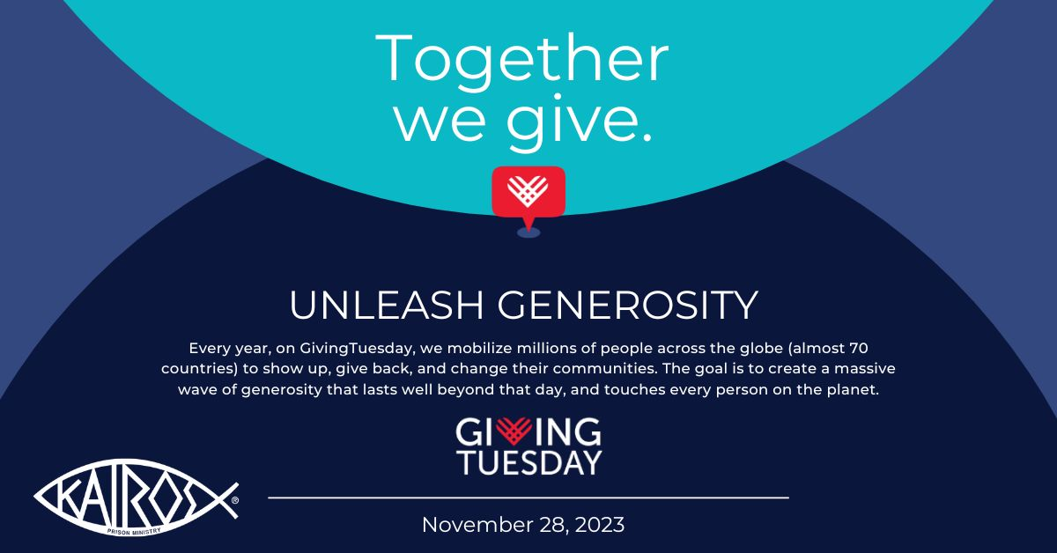
Support [Kairos Prison Ministry International] this Giving Tuesday!
[Kairos Program or Location] is participating in GivingTuesday on November 28, 2023, a global day of generosity inspiring everyone to give back to their community. As we approach the holiday season, let’s remember the true spirit of giving. Kairos has been working tirelessly to bring the light of Jesus Christ to those impacted by incarceration, but we can’t do it alone. We need YOUR help to continue changing lives and touching the hearts and minds of those we serve.
This Giving Tuesday, consider making a donation and spread the word of our ministry throughout your community. Your contribution, no matter the size, will make a significant difference by providing hope to those in need. Can we count on your support?
Ways you can support Kairos on Giving Tuesday:
- Donate to Kairos by visiting [our donation page] or www.kairosprisonministry.org/givingtuesday.php.
- Start a Facebook Fundraiser for Kairos to share with your friends and family.
- Follow Kairos on Facebook, Twitter, and Instagram, then post about Kairos and #GivingTuesday.
- Spread the word by forwarding this email to your family and friends along with a personal note as to why Kairos is important to you.
- Put a reminder on your digital calendar for Giving Tuesday.
2023 has been a unique year as we got back close to full capacity in Weekends and Continuing Ministry, but challenges remain such as the lack of staffing at many facilities that we have no control over. It is in God’s time.
We are encouraged that there have been some #1 Weekends, and more are on the calendar for early 2024. This will allow us to expand the reach of our efforts to impact as many lives as possible. We held training in Africa for the countries of Kenya, Malawi, Nigeria, and Uganda and expect Kairos to be established in these nations in 2024. We also aim to bring Kairos to four states next year. Prisons are asking for Kairos to come into their facilities, as they see the impact on the behavior of the prisoners, and the morale of the prison population overall. God has so much planned for Kairos in 2024 and we are blessed to have all these amazing opportunities to bring the love and forgiveness of Jesus Christ to as many people impacted by incarceration as possible. But we need your support on November 28, so we can fund Kairos Weekends and Continuing Ministry, as well as to recruit new volunteers and organize new start-ups.
Kairos is One Ministry, Three Programs
Kairos is a lay-led, interdenominational Christian ministry in which volunteers bring Jesus Christ’s love and forgiveness to prisoners and their families through three programs:
- Kairos Inside, for incarcerated men and women
- Kairos Outside, for female relatives and friends of the incarcerated
- Kairos Torch, for incarcerated youth
What starts as a Weekend program, a short course in Christianity, is then maintained through Continuing Ministry by the Guests and Participants. Studies have shown that our programs reduce recidivism, prison violence, unite families, and transform lives.

